The Liz Hughes Award for Her Farm Radio
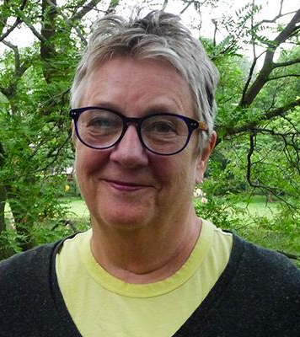
This award recognizes excellent radio programs that serve women listeners. Winning radio programs explore and advance gender equality; for example, by sharing the experiences and opinions of women, addressing topics of importance to women, underlining the role of men in gender equality, etc.

The award is given to the team of people who make this program happen, including the manager(s), producer(s), host(s), presenter(s), reporter(s), technician(s), and others.

In sub-Saharan Africa, women play important roles in farming, family, and the community. Yet they are more likely to experience extreme poverty, malnutrition, and poor health. Women also have less access to and control over resources, including information. That’s why it’s essential for radio programs to serve the needs and interests of women as well as men — when we can contribute to the well-being of women, the well-being of families and communities improves as well.

Winning programs can deal with any subject! In other words, the program does not need to focus exclusively on gender equality issues. For example, you can apply with a program about health, education, agriculture, or a combination of topics. What’s important is that your program, no matter the topic, serves women!

In recognition of their excellent work, the winning broadcast team will receive a certificate and a $1,000 CAD prize. The deadline to apply is October 20, 2023.

How to apply for this award
Any radio station in sub-Saharan Africa can apply for the Liz Hughes Award! To apply, broadcasters or station managers must submit ALL of the following items via email to radio@farmradio.org on behalf of their program team:

- The application form below, complete with detailed answers.
- A recording of your program. (Please submit an episode from 2023.)
- A full transcription of the recorded episode in either English, French, Portuguese, Amharic, or Swahili. The transcription (a written version of your episode, including every word spoken by the host(s) and each guest) ensures that the judges can understand the content and quality of your work.
- A typical program lineup / runsheet in Word or PDF format.
The subject line of the email should be: Liz Hughes Award for Her Farm Radio.

Continue to the next page to see the application form.
Here are some important points to note:

- Stations are allowed to submit more than one application, so long as each application is for a different program "Program” refers to a radio program as a whole, and “episode” refers to an individual broadcast of the program. Please do not submit applications for multiple episodes with your application. Only one episode per program will be accepted.
- Past winners are not eligible to apply for 5 years after they have received the award.
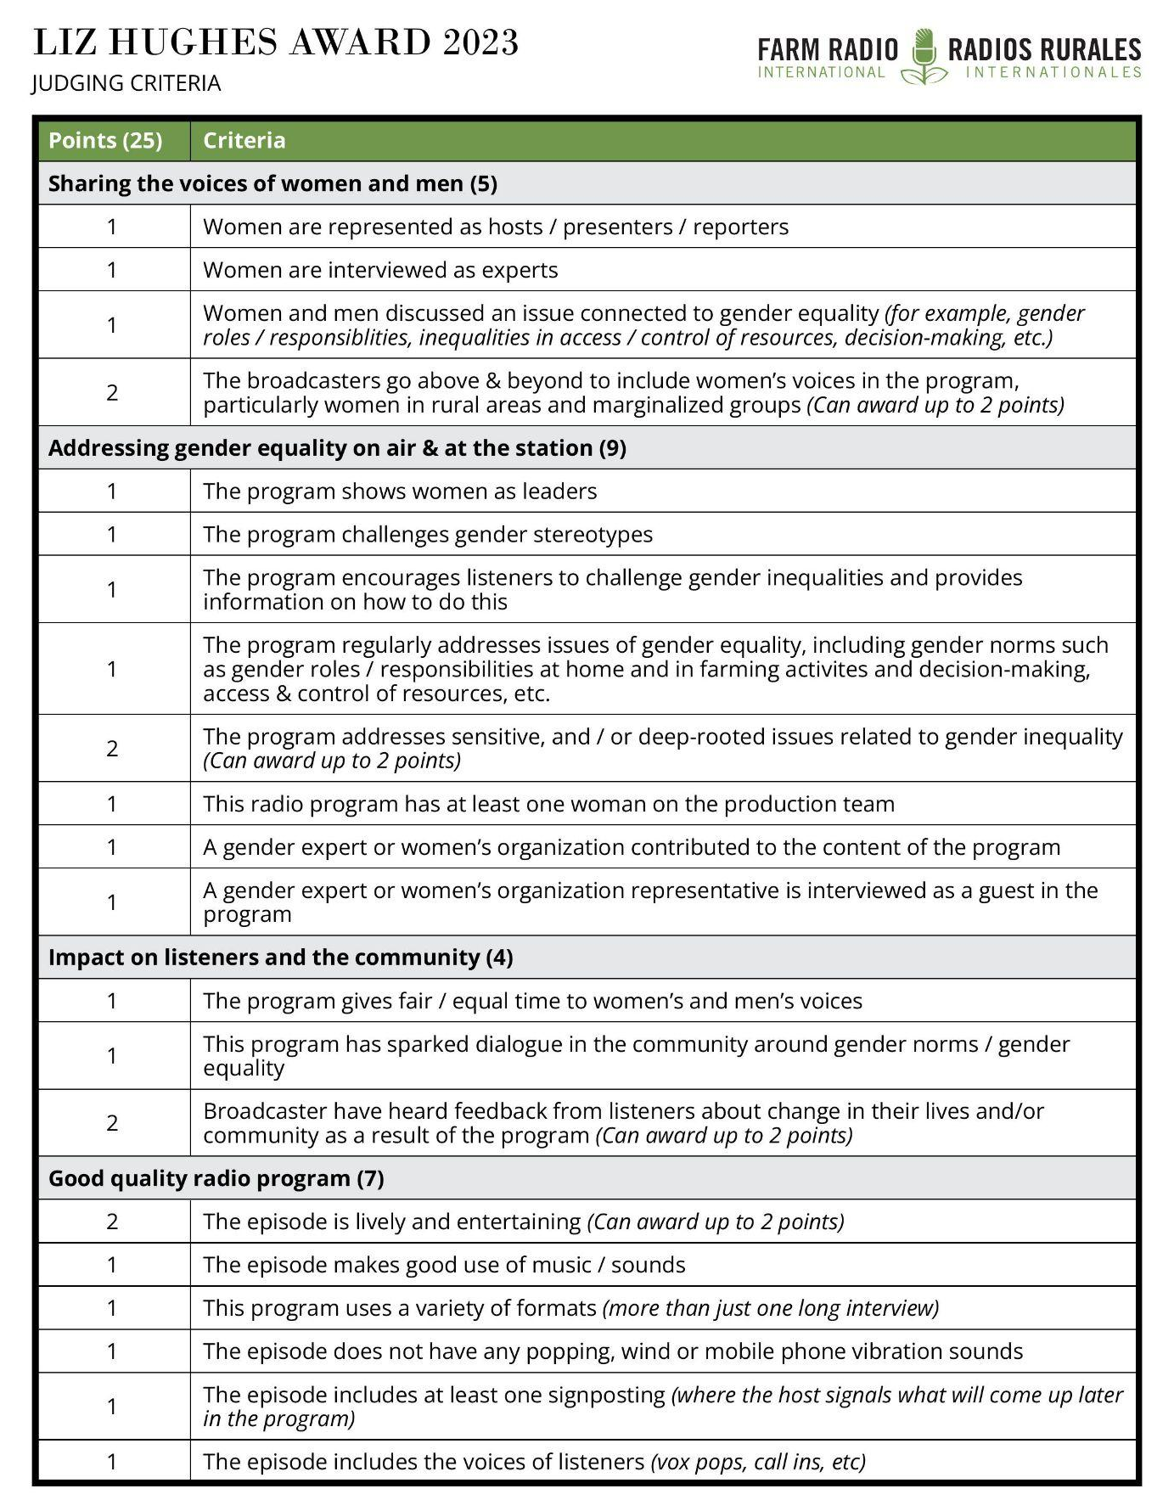

Application form: Liz Hughes award for Her Farm Radio

Please answer EACH of the following questions in as much detail as possible. This will increase your chances of winning the award! Tell us about your work as a broadcaster in detail, use examples from your program, and include information about all of the segments and features of your program. Most importantly, tell us stories about your radio program and the impact of your work.

Applications will be accepted in English, French, Amharic, Portuguese, Swahili, and Hausa.

Station details:

Name of station: _______________________________

Country: _______________________________

City/Region: _______________________________

Station manager: _______________________________

Email address: _______________________________

Phone number: _______________________________

Approximate reach of the station (kilometres): _______________________________

Program details:
Name of program: ______________________________

Focus of program: ______________________________

Duration: ______________________________

Date/time of broadcast: _______________________________

Continue to the next page to see the application form.

List all the staff involved in producing and broadcasting the program, including their gender. This might include the program manager, producer, host, presenter, reporter, technician, and others.

Name | Role in program production | Gender (M/W)

Questions:
- What is the purpose of the program?
- Who is the primary intended audience of the program? What are your listeners’ characteristics—e.g., gender, age, occupation, common attitudes and practices?
- How does the program address gender equality? How do you improve listeners' understanding of gender equality? Please tell us what topics you discuss.
As part of your answer, please tell us about how your program addresses women’s rights, the role of women in decision-making, women’s access to and control of information and resources, men’s roles in challenging gender stereotypes and unequal gender norms, etc.

- How does your program serve women listeners? Please tell a story and give examples.

- How do you produce the program so that it promotes and advances gender equality?
As part of your answer, please describe how you include women and gender equality issues in each step of planning and producing your program. Please refer to the criteria (above) to see what the judges are looking for in your answer.

- Describe how you include women’s and girls’, as well as men’s and boys’ voices in the program, and give examples. Please refer to the criteria (above) to see what the judges are looking for in your answer.

- What challenges have you faced while producing this program? How did you overcome these challenges? Please pick an example that focuses on gender equality. For example, has it been challenging to engage women in the radio program? Has it been challenging to find women experts to interview? Have you had difficulty discussing sensitive or taboo topics on air?

- Your programs may have impacted gender equality in your region. Please describe any changes in your community since the program began and share examples. For example, what feedback have you heard from listeners? What stories have you heard from listeners about how men and women have changed their behaviours at home, at work, in the community, etc.? Are new or more conversations happening in your community around gender equality?

9. You must include an MP3 recording of an episode of your program that was broadcast in 2023. Please include a full transcript of the episode, which is a written version of exactly what was said in the episode and by whom.

